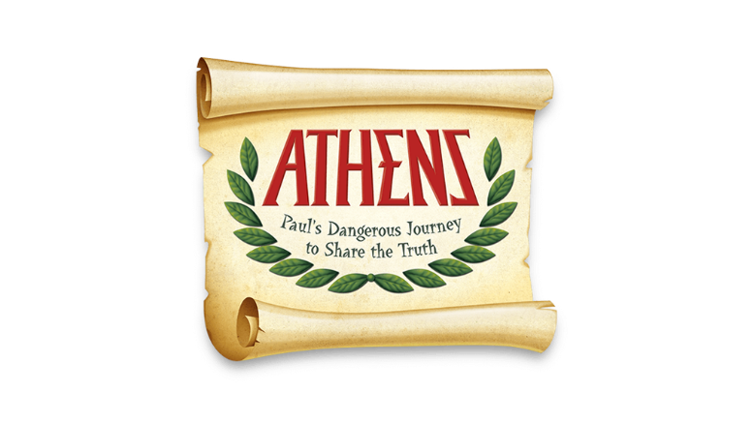

Dear Parents,
Because of COVID, we have not offered in-person VBS for the past couple of years. This year, we are offering VBS once again and would like to invite your child(ren) (ages pre-K – entering 7th grade) to St. Thomas’ VBS. We will travel with Paul as he shares the good news of Jesus. VBS will be held from Monday, July 11- Friday, July 15 from
6:00 pm – 8:00 pm.
We will offer story time, games, crafts, music, and snacks. Our plan is to hold most of the events outside, but we are flexible. So, we are asking you to provide a blanket or beach towel for your child(ren) to sit on, a refillable water bottle, and sunscreen.
On Friday, we will have a brief lesson and then we will enjoy “Olympic” games for most of the night. We will end our week by making ice-cream sundaes.
Traditionally, we collect an offering from the participants. This year, we will make a donation to “ELCA Good Gifts.” The cost is $20 per gift of honeybees.
“These busy bees didn’t get their reputation as hard workers for nothing! Support farmers and healthy honeybee colonies with this buzz-worthy gift. Honeybees provide honey to eat and beeswax to transform into handcrafted soaps and candles, allowing a farmer to start a small business selling their products. And as an added bonus, these little bees boost crop growth on the farm by pollinating plants everywhere they go.”
Again, thank you for sharing your children with us for VBS!
In God’s never-ending love,
St. Thomas Lutheran Church VBS Leaders

